Chicken, Spinach, and Cheese Pasta Bake

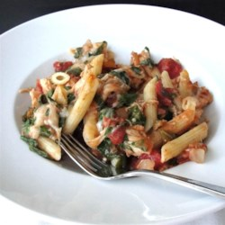
Prep Time 15 min Cook Time 30 min

6 Servings

Ingredients
½ (4 ounce) package mini penne pasta
1 tsp olive oil
1 onion, chopped
3 cloves garlic, minced
3 cups chopped cooked Italian chicken
14 oz Italian-style diced tomatoes
5 oz package spinach
4 oz package cream cheese, softened
1 tbsp Italian seasoning
1 ¼ cups shredded mozzarella cheese

Directions
- Preheat oven to 375 degrees.
- Bring a large pot of lightly salted water to a boil. Cook pasta according to package directions.
- Heat olive oil in a skillet over medium-high heat. Sauté onion in hot oil until tender, 5 to 7 minutes.
- Add garlic and sauté for 1 minute.
- Soften cream cheese in microwave, approximately 45 seconds. Mix in Italian seasoning.
- Mix pasta, onion, chicken, diced tomatoes, spinach, and cream cheese together in a baking dish until the cream cheese coats everything. Sprinkle mozzarella cheese over the pasta mixture. Cover baking dish with aluminum foil.
- Bake for 20 minutes.
Notes
Add bacon, fresh basil, oregano, increase tomatoes to 28 oz, mushrooms, and/or black olives as desired.
Sprinkle with Parmesan cheese before eating.

